***Company programming software will not recognize TD-H8 unless you upgrade the firmware***

(Do not turn on the radio untill step6)

Step1 Install Firmware Upgrade Software

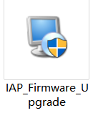

Step2 Open ***IAP_3773_3782***

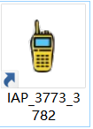

Step3 Connect your radio with a **programming cable, choice corresponding port.**

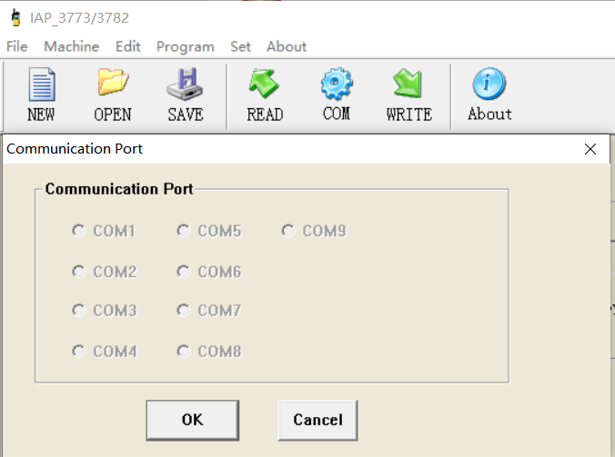

Step4 Click **[OpenFile]** and then select the firmware upgrade file

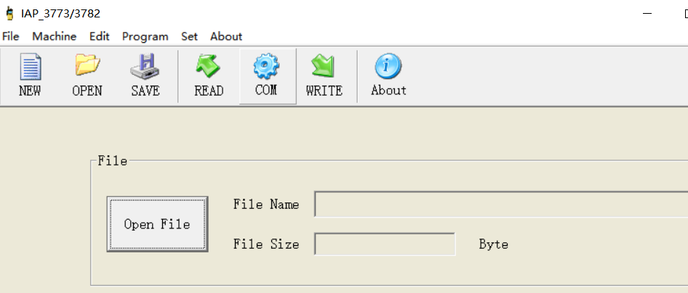



Step5 Press the upper part of the cable kenwood jack through out the upgrade process.

Step6 Click **[Start]** and then **turn on** your radio

***\*There will be a progress bar to indicate the progress of the software when the upgrade starts correctly.\****

***Q1: What should i do if there are not progress bar after I turn on my radio***

***A1: Hold the plug of the programming cable tightly during the upgrade and do it again, never loose the grip.***

***Q2: What should i do if the upgrade fail and the radio cant turn on again.***

***A2:Because the upgrade process may be interrupted, resulting in an incomplete version upgrade of the radio. You need to repeat the upgrade steps again to completely accomplish the upgrade.***

***More question please email suppport@tidradio.com***

**We have also upgraded other features!**

Below are some of the new features we have recently upgraded:  
**1.*scan function**:  
We have added new functionality to the *scan key! Now, **customers can enjoy enhanced features by simply pressing and holding or short-pressing the key. By long-pressing the *scan key**, **users can easily activate the scanning service**, allowing them to search for and monitor different frequencies or channels effortlessly. **On the other hand, a short press of the *scan key will activate the DTMF** (Dual Tone Multi-Frequency) functionality, enabling users to transmit specific tones for various purposes like remote control operations or signaling. This improved functionality of the *scan key provides convenience and versatility, enhancing your overall user experience.  
  
**2.Set MSG-**--Menu---44 key:  
Customers now have the ability to customize the startup screen icon on our TD-H8 ham radio using programming software. **This exciting feature allows users to personalize their devices by choosing their favorite icon to be displayed upon booting.**Whether it's a company logo, a personal symbol, or any other preferred image, customers can now set their desired startup screen icon, creating a unique and tailored experience. This capability adds a touch of individuality and branding to the two-way radio, enhancing the user's overall satisfaction and enjoyment.  
  
**3.MIC Gain function**--menu - 45 key:  
Customers now have the ability to adjust the microphone gain according to their specific needs. **The microphone gain can be adjusted within a range of 0 to 32**. This feature is in direct response to the feedback and demands of our customers, ensuring that they have the flexibility to fine-tune the microphone sensitivity to suit their preferences and optimize their audio experience.

**4.Breath Led**---Menu-43 key:   
Menu 43 "Breath LED Standby" is by default set to off, and the LED light flashes green once every 5 seconds**With the new protocol, additional setting options have been added, including a switch between 5, 10, 15, and 30 seconds, as well as an option to turn the feature off entirely.**.The default setting remains at 5 seconds. This feature allows users to customize the frequency at which the LED light flashes during standby mode, adding a personalized touch to the device's visual display.  
  
**Notice**: In the Unlocked version, we have set a default channel for your convenience, which is 136.025. This means that when you power on the device or switch to the default channel, it will automatically tune in to 136.025. However, please note that you have the freedom to change the channel to any frequency of your preference at any time. We recommend checking the user manual or consulting our support team if you need assistance in programming or adjusting the channel settings. Enjoy the flexibility and versatility of your device as you communicate on the channels of your choice.